**VRINDA STORE Sales Analysis for (2022)**

# Introduction

This repository contains data and analysis on Sales of VRINDA STORE for the years 2022. The data has been collected from official sources and is intended for research and information puroses.

Problem Statement:

Vrinda Store, a retail establishment specializing in various products, aims to optimize its operational efficiency and enhance decision-making processes by gaining deeper insights into its sales data. The store seeks to address the following key areas:

* Gender-wise Sales Analysis: To understand the purchasing behavior of different genders and tailor marketing strategies accordingly, Vrinda Store intends to analyze sales data to determine the distribution of purchases between male, female, and other gender identities.
* Channel-wise Sales Evaluation: Vrinda Store operates across multiple channels, including physical retail stores, e-commerce platforms, and possibly others. The store aims to evaluate the performance of each channel to identify strengths, weaknesses, and opportunities for improvement.
* Monthly Sales Tracking: Monitoring monthly sales trends is crucial for Vrinda Store to identify seasonal variations, predict demand, and make informed inventory management decisions. The store seeks to develop a system to accurately track and analyze sales data on a monthly basis.
* Order Status Monitoring: Efficient order management is essential for providing excellent customer service and maintaining customer satisfaction. Vrinda Store aims to implement a system to track the status of orders in real-time, from placement to fulfillment, to identify bottlenecks and streamline the order fulfillment process.
* Category-wise Sales Breakdown: Understanding the performance of different product categories is vital for optimizing product assortment, pricing strategies, and promotional activities. Vrinda Store aims to analyze sales data to break down revenue by product categories and identify high-performing and underperforming categories.

Overall, Vrinda Store seeks to leverage data analytics to gain comprehensive insights into its sales performance across various dimensions, enabling data-driven decision-making to drive growth and profitability.

## Data Sources

* VRINDA STORE Sales Data for (2022) has been sourced from Kaggle.

### Step Followed

Step 1 : Load data into Microsoft Excel, dataset is a csv file.

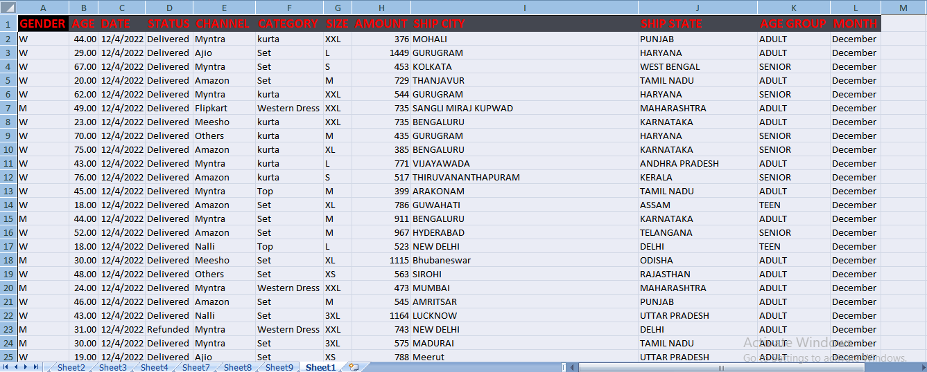

* Step 2 : Data Cleaning and Preparation by Removing any duplicate records or irrelevant columns.
* Step 3 : Ensuring consistency in data formats (e.g., dates ,gender column).
* Step 4 : Handling missing or null values appropriately (e.g., fill with zeros, remove rows with missing data).
* Step 5 : Gender-wise Sales Analysis we use Excel's filtering or pivot table functionality to separate sales data by gender.
* Step 6 : Calculating total sales for each gender category and then visualizing the results using pie charts to compare sales across genders.

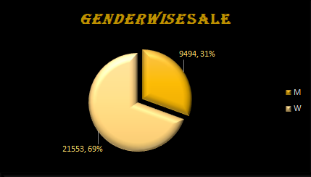

* Step 7 : Channel-wise Sales Evaluation is done by grouping sales data by channels (e.g., physical stores or e-commerce platforms like flipkart ,myntra etc).
* Step 8 : Calculate total sales for each channel by analyzing channel performance by comparing sales figures and identifying trends. To represent it we use pie chart here.

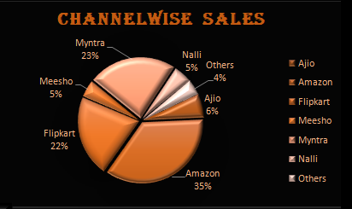

* Step 9 : Monthly Sales Tracking for which weextracted the month and year from the sales date , then group sales data by month and year ,and then calculated total sales for each month.
* Step 10 : for visualizing it we created a column chart plot to visualize monthly sales trends over time.

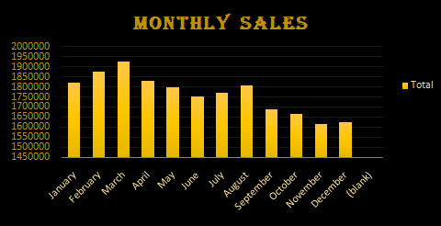

* Step 11 : Order Status Monitoring in this weanalyze the order status column to identify different order statuses (e.g., Returned ,Delivered, Refunded, Cancelled).
* Step 12 : Visualizing order status distribution using a pie chart.

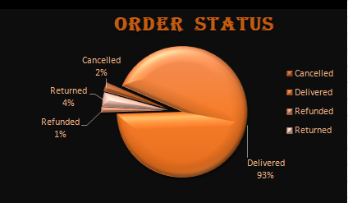

* Step 13 : Category-wise Sales Breakdown for which wegroup sales data by product categories and calculate total sales for each category.
* Step 14 : We are visualizing Category-wise sales using a column chart.

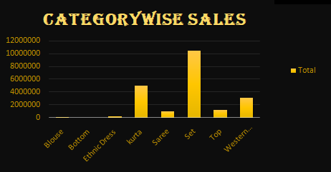

* Step 15 : For gender-wise Age Sales Analysis we use Excel's filtering or pivot table functionality to separate sales data by Gender-wise age. It give us better insight about shopping preference of each gender age group.
* Step 16 : Calculating total sales for each gender age category and then visualizing the results using pie charts to compare sales across genders.

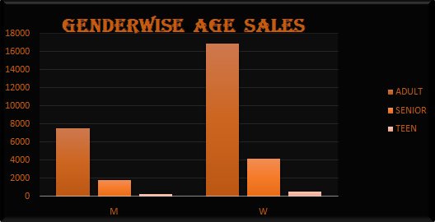

Dashboard After Completion :

* After Completion Dash board looks like this .

